1. **Agenda**:
   1. We are going to look at our very 1st Big O Notation.
2. Remember that run time is how long something takes to run.
3. 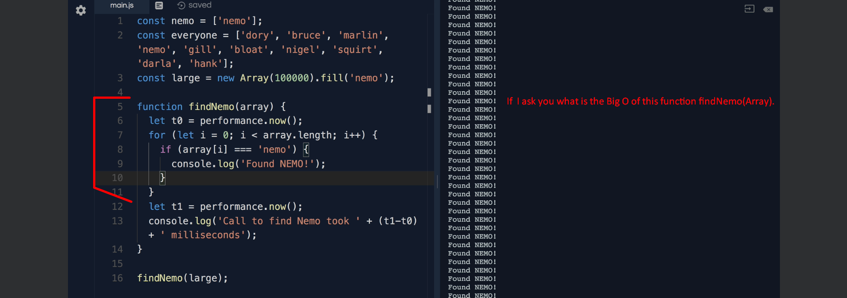
4. So, the question is how does the efficiency of this function increase as we grow input?